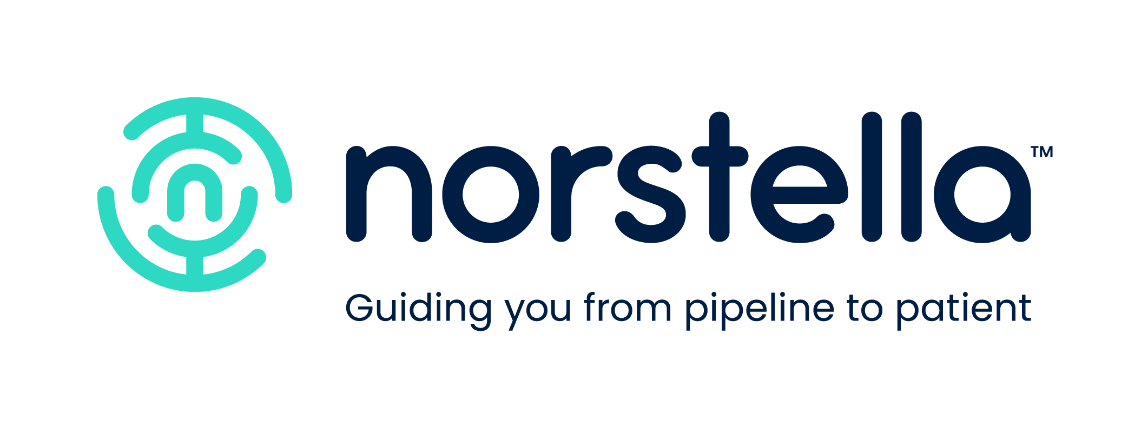
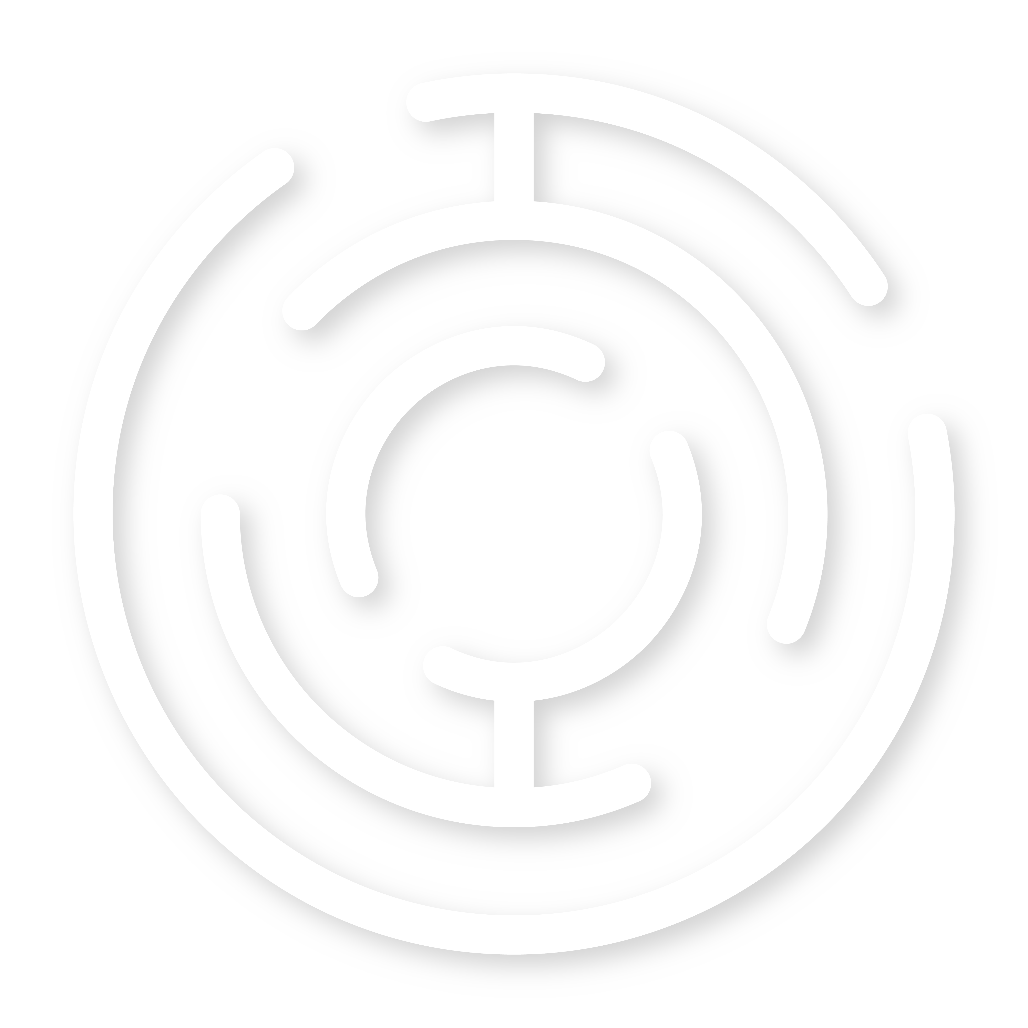

Self-Registration Process for Norstella LINQ RWD Products

IMPORTANT NOTES

- Please note your email address must be defined in RWD product in order to gain access.
- After sign-up, you will receive a “Verify your email” message from Norstella. Due to your organization’s security policies, the email may not appear in your inbox—please check your junk or spam folder if you don’t see it.
- If you already have a login enabled for other Norstella products, you can skip “Self-Registration Steps”.

SELF-REGISTRATION STEPS

- Go to https://cohort.rwd.norstella.com/, you will see the following screen
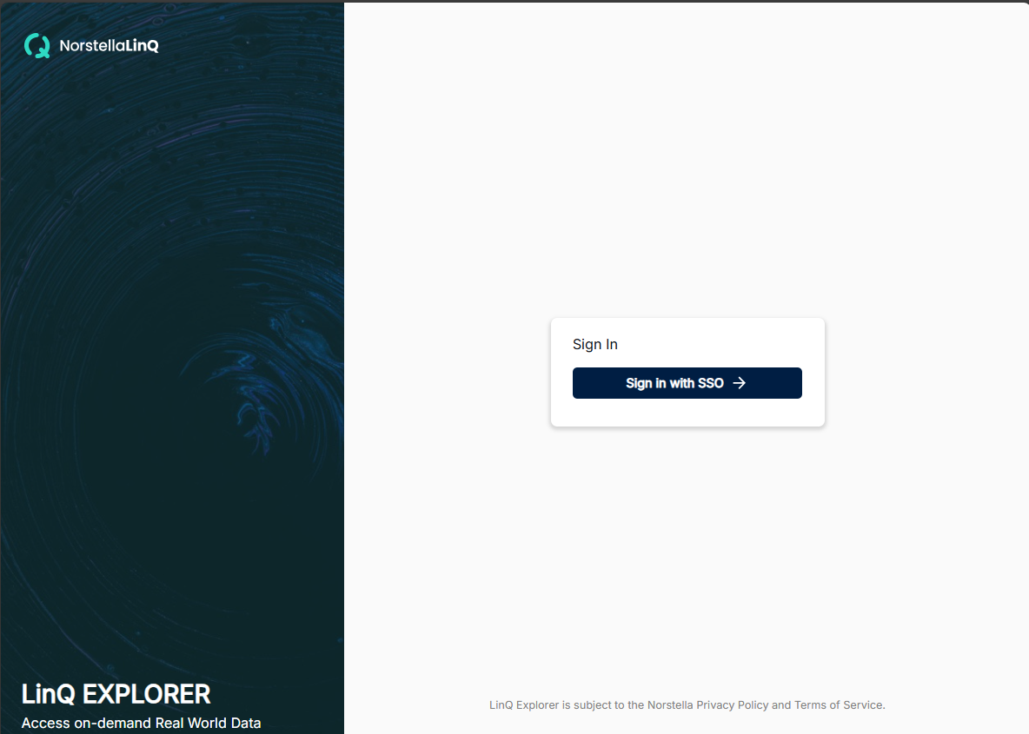
- Click “Sign in with SSO” button, you will see
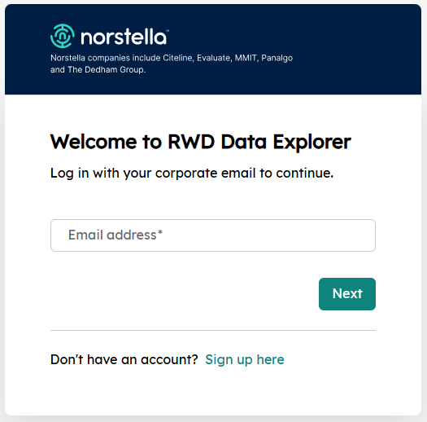
- On this screen click “Sign up here” and on the next screen enter your email address and click continue, you will see the following screen with your email populated
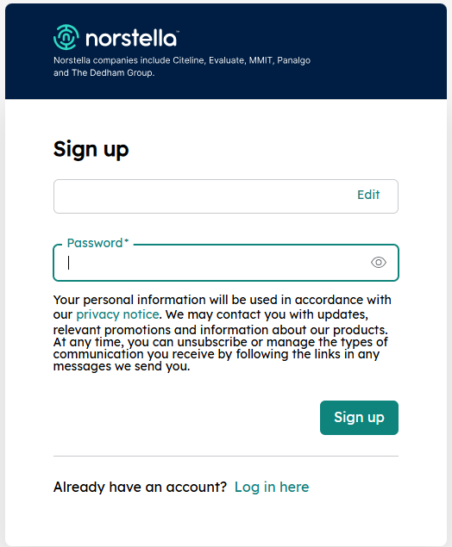
- After providing a password, click sign-up and it will show the following screen
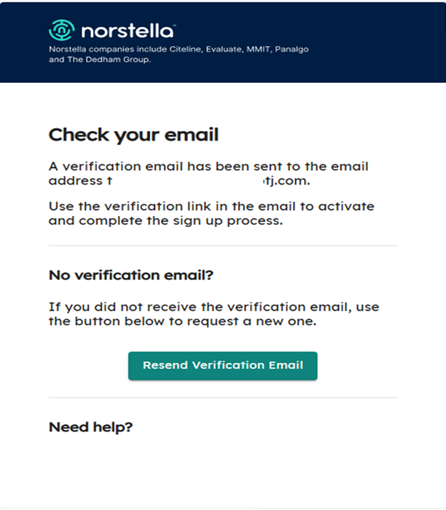
- Open the received email and click “Verify email address” link and verify the email address
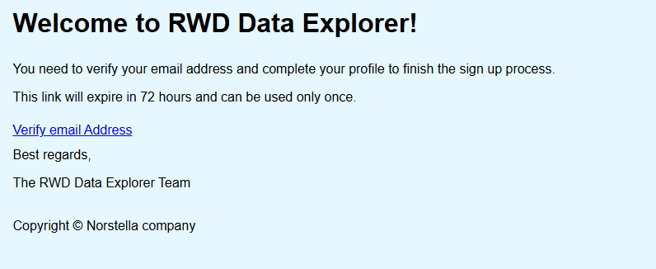

LOGIN AFTER VERIFICATION

- Go to https://cohort.rwd.norstella.com/ and Click “Sign in with SSO” button
- Enter your email and click next
- Enter your password and click “Login” and you should be able to access the Norstella LINQ RWD application
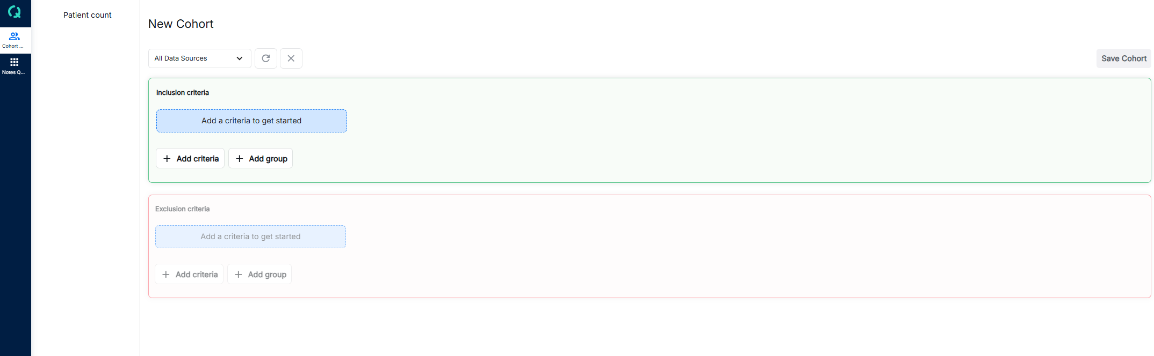
- Bookmark the link https://cohort.rwd.norstella.com/ for future logins

